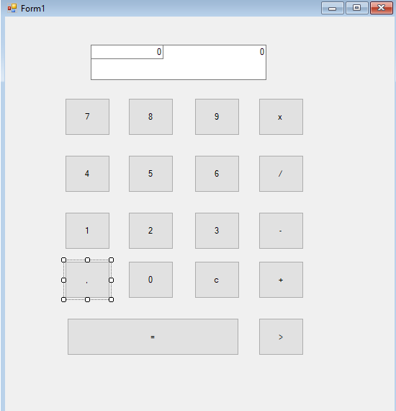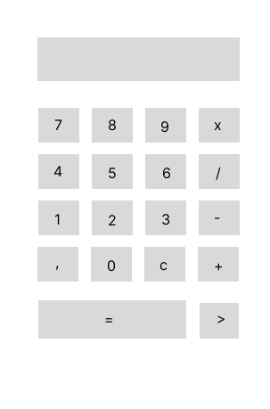LAPORAN UKK ASNIAR 2024 KALKULATOR

public partial class Form1 : Form

{

private const char V = ',';

decimal bil1;

decimal bil2;

int opr;

public bool opr_selesai { get; private set; }

public Form1()

{

InitializeComponent();

}

private void Form1_Load(object sender, EventArgs e)

{

}

private void btn1_Click(object sender, EventArgs e)

{

if(txtdis1.Text == "0")

{

txtdis1.Text = "1";

}

else

{

txtdis1.Text += "1";

}

}

private void btn2_Click(object sender, EventArgs e)

{

if (txtdis1.Text == "0")

{

txtdis1.Text = "2";

}

else

{

txtdis1.Text += "2";

}

}

private void btn3_Click(object sender, EventArgs e)

{

if (txtdis1.Text == "0")

{

txtdis1.Text = "3";

}

else

{

txtdis1.Text += "3";

}

}

private void btn4_Click(object sender, EventArgs e)

{

if (txtdis1.Text == "0")

{

txtdis1.Text = "4";

}

else

{

txtdis1.Text += "4";

}

}

private void btn5_Click(object sender, EventArgs e)

{

if (txtdis1.Text == "0")

{

txtdis1.Text = "5";

}

else

{

txtdis1.Text += "5";

}

}

private void btn6_Click(object sender, EventArgs e)

{

if (txtdis1.Text == "0")

{

txtdis1.Text = "6";

}

else

{

txtdis1.Text += "6";

}

}

private void btn7_Click(object sender, EventArgs e)

{

if (txtdis1.Text == "0")

{

txtdis1.Text = "7";

}

else

{

txtdis1.Text += "7";

}

}

private void btn8_Click(object sender, EventArgs e)

{

if (txtdis1.Text == "0")

{

txtdis1.Text = "8";

}

else

{

txtdis1.Text += "8";

}

}

private void btn9_Click(object sender, EventArgs e)

{

if (txtdis1.Text == "0")

{

txtdis1.Text = "9";

}

else

{

txtdis1.Text += "9";

}

}

private void btn0_Click(object sender, EventArgs e)

{

if (txtdis1.Text == "0")

{

txtdis1.Text = "0";

}

else

{

txtdis1.Text += "0";

}

}

private void btnkali_Click(object sender, EventArgs e)

{

bil1 = Convert.ToDecimal(txtdis1.Text);

txtdis2.Text = "*";

txtdis1.Text = "";

opr = 1;

opr_selesai = true;

}

private void btnbagi_Click(object sender, EventArgs e)

{

bil1 = Convert.ToDecimal(txtdis1.Text);

txtdis2.Text = "/";

txtdis1.Text = "";

opr = 2;

opr_selesai = true;

}

private void btnkurang_Click(object sender, EventArgs e)

{

bil1 = Convert.ToDecimal(txtdis1.Text);

txtdis2.Text = "-";

txtdis1.Text = "";

opr = 3;

opr_selesai = true;

}

private void btntambah_Click(object sender, EventArgs e)

{

bil1 = Convert.ToDecimal(txtdis1.Text);

txtdis2.Text = "+";

txtdis1.Text = "";

opr = 4;

opr_selesai = true;

}

private void btnsd_Click(object sender, EventArgs e)

{

if (opr_selesai == true)

{

bil2 = Convert.ToDecimal(txtdis1.Text);

}switch (opr)

{

case 1:

txtdis1.Text = Convert.ToString(bil1 * bil2);

break;

case 2:

txtdis1.Text = Convert.ToString(bil1 / bil2);

break;

case 3:

txtdis1.Text = Convert.ToString(bil1 - bil2);

break;

case 4:

txtdis1.Text = Convert.ToString(bil1 + bil2);

break;

}

}

private void btnclear_Click(object sender, EventArgs e)

{

txtdis1.Text = "0";

bil1 = 0;

bil2 = 0;

txtdis2.Text = "0";

}

private void btnhapus_Click(object sender, EventArgs e)

{

txtdis1.Text = txtdis1.Text.Remove(txtdis1.Text.Length - 1);

{

if ((txtdis1.Text == "") || (txtdis1.Text == "-")) ;

}

txtdis1.Text = "0";

}

private void btnkoma_Click(object sender, EventArgs e)

{

if (txtdis1.Text.Contains(',') == false)

txtdis1.Text =txtdis1.Text + ",";

}

}

}

LINK GITHUP